Creating Implicit Surfaces
for a Fluid Dynamic System

Jamie Briens

Masters Thesis
MSc Computer Animation

National Centre for Computer Animation
Bournemouth University

September 2005
1 Introduction 3
2 Implicit Surfaces 3
2.1 Implicit Functions 3
2.2 Voxelisation of Space 4
2.3 Creating the Data Set 4
2.4 Marching Cubes 4
2.5 Problems Encountered 5
3 Blobby Surfaces 5
3.1 Description 5
3.2 Functionality 5
3.3 Reason for Use 6
3.4 Problems Encountered 6
4 Pipeline 6
4.1 OBJ to CFD Converter 7
4.2 OBJ Importer 7
4.3 CFD Exporter 8
4.5 CFD to RIB Converter 8
4.5 Shader 8
4.6 Rendering 10
5 Conclusion 15
6 References 16

1 Introduction

This thesis explains the theory behind and the implementation of creating implicit surfaces across a fluid dynamic system. This implementation uses the fluid dynamic system produced by Alexander Kaminski to get the necessary data used to produce the final rendered images. The purpose of the implicit surface is to create a visual representation of the fluid particles in the fluid dynamic system. This is done to enhance the visibility of the fluid motion and direction, as particles on a screen can give an overall motion but with the rendered version you can see what is going on underneath. To tie the implicit surfaces with the fluid dynamics system, a pipeline was also created to allow data passing, and this is also discussed in this thesis. Implicit surfaces were implemented but due to problems when used with large amounts of spheres, renderman's blobby surfaces were used to produce the final results. Both methods and implementations have been discussed, but the blobby surfaces are the ones seen in the video clips produced. In future work, the implicit surfaces will be chosen as they produce more accurate results when bug free.

2 Implicit Surfaces

Surfaces are generally formed with primitives such as lines, planes and boxes. Implicit surfaces are formed using an isosurface of a function. An isosurface represents a surface that has a constant value throughout its volume. The aim of this project is to implement the Marching Cubes algorithm to create an implicit surface from a set of spheres and to integrate this into a pipeline along with the fluid dynamics system to produce a rendered fluid animation.

2.1 Implicit Functions

Functions can be used to form implicit surfaces. The function used here is that of a sphere:

r²=x²+y²+z²

r = radius
x,y,z = co-ordinates of a point in the sphere

This only works with spheres based at the origin. To find out points for any given sphere it is extended to:

r²=(x-x₀)²+(y-y₀)²+(z-z₀)²

r = radius
x,y,z = co-ordinates of a point in the sphere
x₀,y₀,z₀ = co-ordinates of sphere’s centre

Using the data from the fluid dynamic system, sphere information is obtained from the particle origin co-ordinates. The particles are all of the same fluid type, so the radius is assumed to be constant for each one.

The function needs to be able to take any point inside, outside or on the surface of a sphere and be able to tell which of these it is. The data is all known in the given formula, but if the radius is ignored and the right hand side is worked out based on the point currently being looked at and the sphere centre, it gives the effective radius the point is from the sphere. This radius is then compared to the sphere’s real radius. If they are the same then the point is on the surface, if it is less than the real radius it is inside, and if it is greater than the real radius it is outside the sphere.

2.2 Voxelisation of Space

The method to create the surface requires that the space be divided up into voxels. To increase efficiency it is necessary to minimise the space looked at. This is done by creating a bounding box around all the spheres. The bounding box is created by calculating the minimum x, y and z co-ordinates and maximum x, y and z co-ordinates of all the spheres. Once this has been done the space can be divided into a 3-Dimensional array of divided space in between these two sets of co-ordinates. The more the space is divided smoother the spheres will appear after the surfaces are drawn.

To incorporate the fluid dynamics, the voxels must be at least the same used in the fluid dynamic system. However the more voxels used the better and typically there should be 64 voxels per fluid dynamic voxel to get a visible result. This number ensures that there are enough to produce the detail required, but small enough so that it doesnt take to long to calculate the results.

2.3 Creating the Data Set

Now that the space has been divided into voxels, a 3-Dimensional array of values is created for use in forming the surfaces. Each voxel is looped through in the defined space and for each vertex on that voxel it is determined whether the vertex is in, on or outside any of the spheres. If the vertex is inside or on the surface of the sphere the vertex is set with a value of '1'. If the vertex is outside the sphere and it hasn’t already been set to '1' by another sphere, then it is set to '-1'.

2.4 Marching Cubes

This algorithm uses the data sets that have been created to form the implicit surface of the spheres. As it's name suggests, the algorithm uses a cube by cube approach. For each cube it checks to see whether the value of each vertex is below a given isolevel. The isolevel is the number given to check for the surface. Previously the vertices were given values of '1' and '-1' to represent inside and outside the sphere respectively. This means that the actual surface would lie between these values, so an isolevel of '0' is used.

If all the vertices are '1', or all the vertices are '-1' then the cube is completely inside or outside the implicit surface and so can be ignored. If the vertices are a mixture of values then they lie on the surface to be represented. Now the position of where the surface cuts the cube needs to be found. There are 256 different ways to cut a cube with a surface with 15 different types of cuts. There are pre-calculated tables available that are provided as lookup tables to reference the positions. Once the vertices of a surface voxel are determined as being inside, these tables are then used to lookup the values of the cube edges that were crossed. Then the vertices on the given edges are linearly interpolated to calculate points on the surface.

The surfaces for each cube are a number of triangles. These triangles are then drawn to form the final surface.

2.5 Problems Encountered

When originally implementing this, on initial tests there were no problems with it. However, once integrated into the pipeline, more particles were being rendered and it became apparent that holes were being displayed. Increased numbers of voxels were used to see if it was a cause, but the results produced didn't seem to change. As time was running out, an alternative solution had to be used, so that there was a renderable version of the fluid dynamic system. This alternative solution was rendermans blobby surfaces, which is built into renderman. The advantage was that the code was already written and working, but the down side was that it wasn't configurable enough to produce what was needed, and thus produces a less precise image of the fluid. In future work, more tests will be run to find the cause of the hole that appear, and the implicit surfaces will go back to being the primary surfaces being used as they are more configurable.

3 Blobby Surfaces

3.1 Description

Renderman has implemented its own solution to the implicit surfaces problem. It uses the same idea that a sphere is a blobby object that can be influenced by other blobby objects around it, and uses iso-contours to represent the final surface.

3.2 Functionality

Blobby objects in renderman have three attributes that are used when creating them:
- An x, y, z co-ordinate to represent the blobby object's origin
- The radius of the blobby object, determined by x, y and z values so that ellipsoids can be used
- a value that is constant across it's surface.
This is the same idea used in implicit surrfaces, but it is noted here as these are the values that are passed to the function through the .rib files. These are the only values given when calling the function.
The origin is needed to determine where the values are being given from. References to point source lights are commonly used for this as an example. Point source lights radiate light from a given point much like blobby surfaces radiate values from their origin. The values radiated determine whether they are in, on or outside the surface, and are found through the use of implicit functions. Renderman uses field strengths that drop to zero as they reach the pre-determined radius.

3.3 Reason for Use

Blobby objects were used in this project due to some bugs found in the implementation of the implicit surfaces. These bugs were not seen when first written as the rendered images showed no problems. When they were then used on a set of data obtained from the fluid dynamic systems, holes appeared throughout the set of particles, and the solution to this problem was not found in time. To have a renderable product working, blobby surfaces were used to get a clear idea of what was going on, and although they were not as accurate as the implicit surfaces might have been, they gave a clearer image, and therefore a better animation sequence at this point in time. As the surfaces are now being calculated at the renderman end, the rib files get produced a lot faster, but the rib files themselves now become a lot slower to render.

3.4 Problems Encountered

Due to the data being passed, and the method used, the final render looks more 'blobby' as a result. Using the implicit surfaces would have produced a more accurate representation of the surface, due to the increased divisions within each voxel. Also the surface only uses spheres, and to be more accurate still, the boundary walls on all 6 sides should be implemented so there are no gaps between the fluids and these surfaces. Blobby surfaces are limited as they are coded with renderman and you can't change everything about them. Implicit surfaces having been hand coded, are completely customisable and integratable into the code. Ideally every voxel in the fluid dynamic system should have 64 voxels within it to produce an accurate result.

4 Pipeline

The fluid dynamics system and the implicit surfaces were implemented completely seperately from each other. During implementation, test data was used by each and no data passing was necessary. As it came to the point where data did need to be passed, a pipeline had to be created to enable the passing of data backwards and forwards between the two systems.

Firstly, object data from modelling software needed to be passed to the fluid dynamic system. This would take that data and create its set of particles to be used in simulation. Once the simulation had run, this set of particles then needed to be exported to a file format that both programs could understand. A file format was created for the two with a structure based on how it would be read into the implicit surfaces, using tokens the implicit surfaces would recognise. It is more important for it to be compatible with the program that is importing the data, as the program outputting can do pretty much anything, whereas the programming getting input has to look for certain data, needs certain tokens or file layout to get the relevant data it needs.

So now the fluid dynamic system has had all of its data input and output, the implicit surfaces program needs to have the data read back in. Once this data is read in, it needs to create its data, and then output the results into renderman format ready for rendering, and also including the shader.

While work was being done using the fluid dynamics system, a seperate function was implemented to the implicit surfaces program to read in an .obj file, so that it had some test data to work on while the fluid dynamics were being independantly created.

Once all the importing, converting and exporting was done for both the fluid dynamics and the implicit surfaces, a set of ribs files were produced to render for each set of animation.

4.1 OBJ to CFD Converter

This was implemented to provide a quick and easy means to display an existing model as a final rendered still. The converter simply takes an existing OBJ file, which can be exported from most of the popular modelling software.

Using the OBJ file as a data source, it loops through the file token by token looking for the ‘v’ token. Before this loop, the header information for the CFD file must be written, which is the token ‘f’ for frame, followed by the frame number which is hard coded to ‘1’ as this is a single frame, and then followed by the number of particles. The number of particles is achieved by looping through the OBJ file completely, counting the number of occurrences of the ‘v’ token. During the second loop of the file, when getting vertex positional data, the program looks for the ‘v’ token, and writes the following 3 numbers to the CFD file, as these are the x, y and z co-ordinates of a model vertex. After it has done this for every vertex in the OBJ file, it ends by writing ‘e 0’ at the end of the CFD file to signify the end of the file.

This produces a valid single frame CFD file, which can then be used in the CFD to RIB converter to produce a renderable RIB file to be used in conjunction with the desired shader.

4.2 OBJ Importer

The code behind this is very similar to the OBJ to CFD Converter. It too gets the vertex information from existing models, but this code is written into the fluid dynamic program. Once the data is found, rather than writing it out to CFD file, the information is stored in a particle array. This particle array was originally hard coded to provide blocks of particles to be used in test simulations. The OBJ Importer provides an alternative means of getting an initial set of particles, and was introduced into the program as a means to create a tool to ‘melt’ a model. As it stands right now the vertices are all that are put in, and this creates a hollow set of points. Being hollow, there are more faces that are adjacent to air faces, and this leads to slightly inaccurate behaviour for the desired effect. In future versions of this software it is planned to write a program to ‘fill’ the hollow set of particles by linear interpolation between the existing vertices.

4.3 CFD Exporter

This is code again written into the fluid dynamics program. For every frame of data it sends to OpenGL it now also calls a function to write its data out to the CFD file. It writes the token 'f' first to signify a new frame, followed by the frame number and the number of particles currently in the system. After this it loops through every existing particle in the system and writes its position out starting with the token 'p' and then its x, y and z positional values seperated by spaces. Once it has reached the end of the frame it writes the 'ef' token followed by the frame number to signify to the CFD to RIB converter that that frame has ended. Finally, at the user's discretion the fluid system is brought to an end when they decide the simulation has fulfilled its purpose. When the user presses the key to stop the simulation, it sends to file 'e 0' to signify that all data for this scenario has been sent and the file is at an end.

4.5 CFD to RIB Converter

After a valid CFD file has been written, either as a test frame from OBJ data, or a full file created by the fluid dynamic program, the CFD file is then read into the CFD to RIB converter. Firstly the RIB file needs to be written to, to set up the render attributes. Also the shader line is written here so that it is applied to all the geometry below. Once this has all been written, the CFD file is then read line by line, to find the particle positions for the current frame. Then the particle data is written to the RIB file so that it matches the function call for the Renderman Blobby function . For each frame, a seperate RIB file is produced.

For the blobby function call itself there are a few bits of data that must be passed to it. Directly after the function call, the number of particles must be declared. After this, the list of particles indices must also be listed along with an ellipsoid id. The id is preset and is constant for every call, but the indices are multiples of 16, and thus a loop has to be run for every particle in the system to generate its index. After this, it then groups the particles. As only one fluid body is to be created, all the indices are included together. Before the indices are put in, a group id of '0' is given, followed by the total number of particles. Then follow the indices of all particles, again written via loop. After this one final loop is used, this one actually plots the blobby object. A 3-Dimensional size is given preset to '1 0 0 0 0 1 0 0 0 0 1 0'. This gives a sphere of radius 1. Changing these values can give different sized spheres when kept uniform, or an ellipsoid of non uniform dimensions if required. Following the size ,the particle x, y and z co-ordinates are then printed, followed by the isolevel which is hardcoded to '1'.

4.5 Shader

Fluid shaders were looked into, but lack of documentation for Renderman versions led to a simple opacity shader being used. This simply decreases the opacity value the further away from the surface it is. This results in solid colour appearing at the edges and eventually being completely transparent in the centre. This is useful as it highlights the surface that has been created. For future versions, more time will be spent looking into better ways to shade the final image, as although it highlights the surface, it doesn't give any realism. Realism was originally desired, but was later realised as not being important in the final render, as the motion, and the surface creation had higher priority.

When looking at shaders, not only the surface should be looked at though, and more research will be done into this. As the surfaces are fluids, different flows are happening within the object as a whole. Were only the surface to be shown then none of what is happening underneath would be visible. Thus the internal particles must be used in the shader, using their velocities to feed into the shader.
This accounts for the fluid itself, but there is yet more that can be built into a shader for the fluid, as currently the fluid has been used standalone. Were this to be enhanced yet further other factors should be looked at such as reflections and refractions of the water, so that were the fluid placed into a scene, it would look realistic within its environment.

4.6 Rendering

Once all the RIB files were produced they were run through a simple render shell script.Using implicit surfaces, frames took about a minute to render. When blobby surfaces were used the render times went up more. The time taken to render depending on the number of blobby objects set to render, and as each blobby object tests to see if it is within the influence of every other blobby object the time difference is exponentially increased with a higher number.

Several different simulations were run on different computers to test the completed programs:

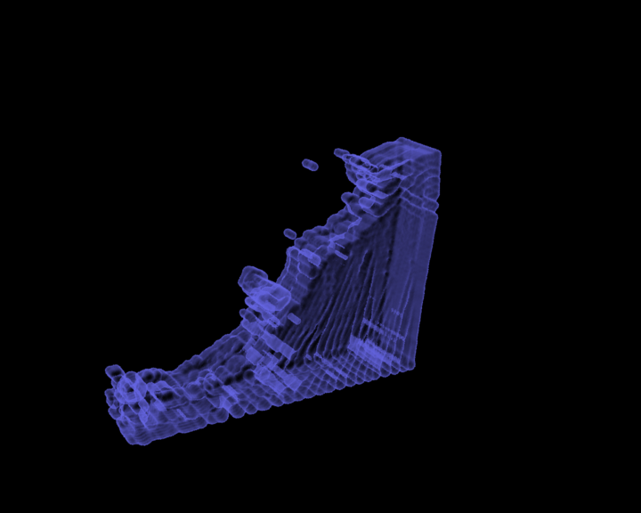
Figure 4.6.1

Firstly a block of water was set up on the right hand side of the grid(Figure 4.6.1). This is allowed to free fall, and was expected to hit the left wall and splash back, which it did. There are a few particles that get stuck on the boundary, this is a general problem with the fluid dynamic system.

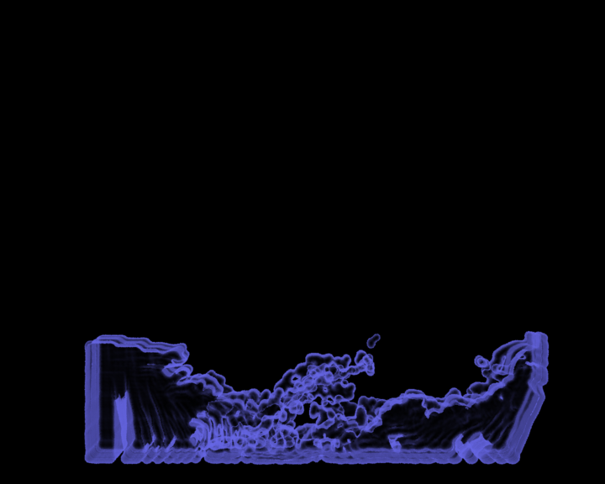
Figure 4.6.2

Then another block was added on the left hand side to get a splash when the 2 sides met in the middle(Figure 4.6.2). One block drops slightly before the other, resulting in one side going under and one side going over in the resulting crash which produces a realistic effect.
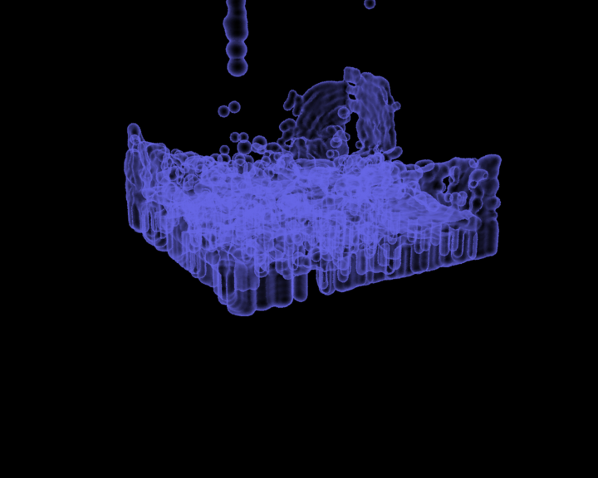
Figure 4.6.3

Another test was run to see what would happen if the fluid was in the corner of the grid(Figure 4.6.3). The result is like a more 3-Dimensional version of the single block test, where the fluid expands in width and depth, and results in splashing against the two opposite walls.
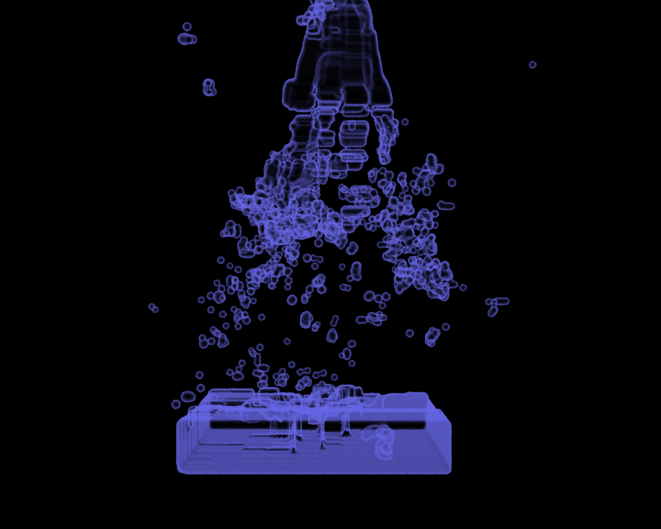
Figure 4.6.4

A body of fluid was left at the bottom of the grid, and a block of fluid was then dropped from the top(Figure 4.6.4). The first time this rendered, the dropping fluid exploded, and so a full render is not available as of the time of printing. However this has been fixed and renders are being redone on this.
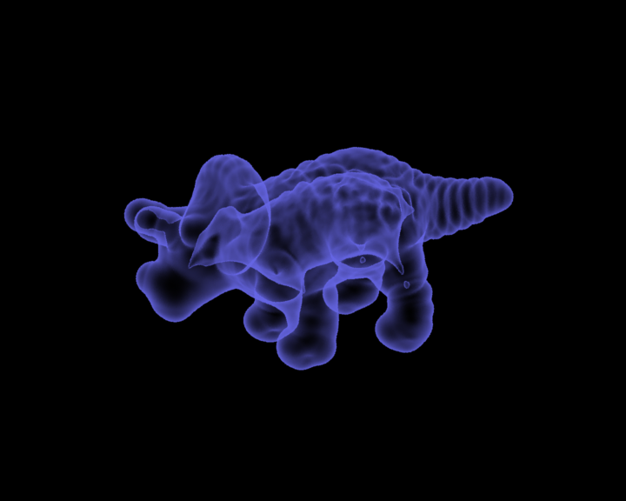
Figure 4.6.5

The OBJ importer was also tested with a triceratops OBJ file(Figure 4.6.5). This behaved as expected, and dropped fairly quickly due to the model being hollow. Future tests will be run on this when a model filler is implemented as the particles fell quicker due to space inside, meaning more air faces. Were it filled there would be less faces, and pressure would have a proper effect on the resulting direction of the particles.

5 Conclusion

Due to complications with the implicit surfaces, the final rendered result was not what was originally planned. It does work well to show the surface, but the way blobby surfaces work within Renderman, a degree of accuracy seems to be lost. Work is intended to be continued on the implicit surfaces to find the bug that causes it to create holes, on large sets of data, and then re-render the images to produce more accurate images.

The shader used was also just to demonstrate the surface. Once a realistic surface representation has been produced then work on a fluid shader will be started, to make a photo realistic render of the fluid dynamic system. The fluid dynamic system is currently only being used to display a liquid effect, but can be extended to a proper fluid system incorporating both liquids and gases. When this happens, further shaders can be written for some gas simulations such as smoke.

The fluid dynamic system was re-written from it's previous version, to create a more realistic system. It is also planned to extend the fluid dynamic system to include thermal variables, and create melting fluids. Using this, it would be possible to take two different models, and melt them into each other using a locator to act as a kind of magnet. Then the implicit surfaces will work across the merged set of particles. It is also planned to be able to colour particles within these models, starting off with the two objects being two seperate colours, and when they melt merge the colours. This will be done through shaders.

The work has all been programmed in C++ and OpenGl was used to view intermediate results. Building on the C++ part of the work in the future, this project is intended also to have a working Maya C++ API version, so that artists may use it as a plugin in their work.

Integration is another aspect to look at in future. The code was done separetly now, and some code had to be moved to the implicit surfaces to take the load off the fluid dynamics. However the OpenGL display accounts for a lot of the slow down, and if the whole process is done using .obj files the process can be fully automated. This would give a smaller pipeline, as the need to import and export data is reduced and would speed up the process. The OpenGL version would be kept for development on the tool, but a seperate version could be implemented for pure rendering usage.

Overall the project has achieved much of what was intended. The motion of the fluids is realistic, aside from the few bugs where particles get stuck to walls. The surfaces work quite well, and show fluid flow, and the resulting particles that break away from the body surface to create splash droplets.

6 References

[1] Bloomenthal, J., Polygonization of Implicit Surfaces, Computer Aided Geometric Design, Issue 5, 1988

[2] Bloyd, Cory Gene. Cube edge lookup tables. (1997).

[3] Bourke, P. Polygonising a scalar field.
http://astronomy.swin.edu.au/~pbourke/modelling/polygonise (1997).

[4] Chandrajit B., Surface Fitting with Implicit Algebraic Surface Patches, in Topics in Surface Modeling, H. Hagen. editor, pp. 23-52, SIAM Publications. Phildelphia, PA, 1992.

[5] Graves, G., The Magic of metaballs, Computer Graphics World, May 1993

[6] Lingrad, D et al. The Marching Cubes.
http://www.essi.fr/~lingrand/MarchingCubes/algo.html (2002)

[7] Paradox, Vivid. Marching Cubes Based Polygonisation.
http://www.cfxweb.net/modules.php?name=News&file=article&sid=199 (April 2005)

[8] Sharman, J. The Marching Cubes Algorithm.
http://www.exaflop.org/docs/marchcubes/ind.html (June 2005).

[9] Shen, C., O'Brien, J. F., Shewchuk J. R., "Interpolating and Approximating Implicit Surfaces from Polygon Soup." The Proceedings of ACM SIGGRAPH 2004, Los Angeles, California, August 8-12.

[10] Wyvill, B, Wyvill, G., Field Functions for Implicit Surfaces, Visual Computer, Issue 5, 1989

